Enterprise Team Foundation Server Scrum

# What is this?

The Enterprise Team Foundation Server (ETFS) service currently supports a single process template for Scrum. The ETFS Scrum Process Guidance endevors to provide users with a best practice approach to utilize ETFS to run a Scrum team. Other goals include:

* Providing a uniform Scrum experience on ETFS
* Definition of Roles within a team
* Getting the team talking the same terminology

# Process Guidance for ETFS Scrum

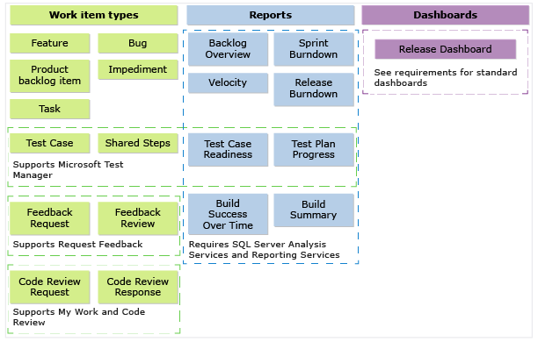Using the work item types (WITs), reports, and dashboards shown in the illustration, teams can plan projects, then track, view, and report their progress. These artifacts are created when you create a team project using the Visual Studio Scrum process template.

In addition to WITs, reports, and dashboards, teams have access to a set of shared work item queries that your team can use to track information, analyze progress, and make decisions.

# Plan and track using work item types

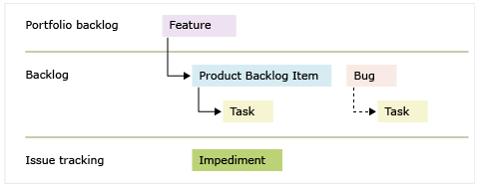Rules of Thumb:

Epic – functionality that spans mutliple releases.

**Feature** – a “within this version” piece of functionality. The intention is to complete a feature within one release.

**Product Backlog Item** – complete within a single sprint. PBI’s that cover multiple sprints should be broken down into small PBI’s.

**Bug** – a defect to fix

**Task** – the time tracking work item type. Burndowns depend on using Tasks to track progress

# Scrum using the ETFS Scrum Process Template

What is this guide?

The ETFS Scrum Process Guidance is meant to provide the Framework, Values, and Principles that serve as process guide. This guide is not a prescriptive set of guidance that will solve every problem.

## What is Scrum?

* Scrum is an innovative approach to getting work done
* Scrum is an agile framework for completing complex projects
* Scrum is about people
* Scrum is NOT a software development methodology
* Scrum is NOT magic or a silver bullet

## What is Agile?

* More of a philosophy
* An approach to product development
* Adaptive – there is no “THE AGILE METHOD”
* To “be agile” put the values and principles into practice
* The Scrum process supports Agile values and practices

## Scrum Framework

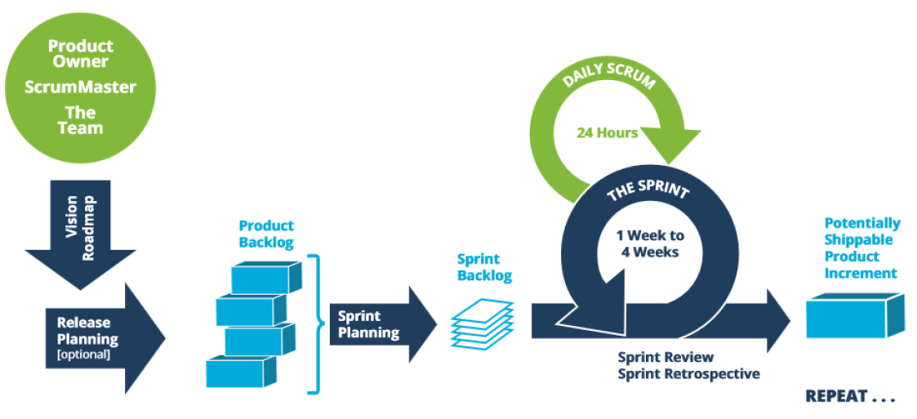

### Vision & Roadmap

* The Product Owner works with Stakeholders, SMEs, etc. to articulate the Vision
* The Product Roadmap is an evolving plan – it is subject to change as details emerge or based on what is happening in our organization, our market and with our customers
* A Product Roadmap for a particular product that will evolve across versions or releases will have more detail the closer we are to the point in time on the Roadmap
* Other details will intentionally be vague the further out those milestones occur because “we don’t know what we don’t know”

The Product Roadmap can help an Organization or Team:

* Answer how the Product will evolve across releases or versions
* Facilitate dialog between Stakeholders, Product owner and Team
* Very simply show essential, high level milestones for the Product or for Products prioritized by the Organization
* Focus the Product Backlog as the Team moves to execute on the Vision in the high level timeframe identified on the Roadmap

Example Product Roadmap:

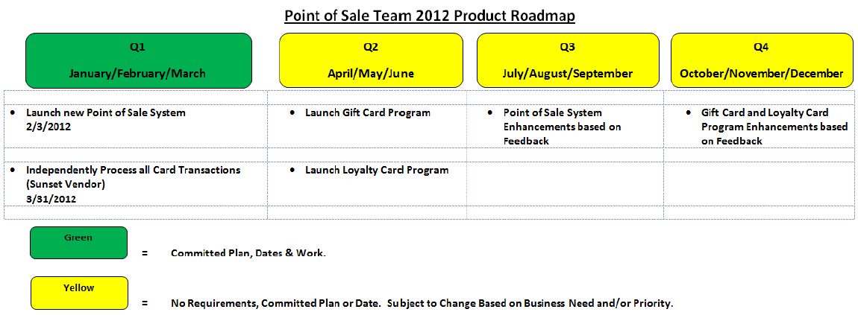

### Define the Product Backlog using Product Backlog Items (PBIs) and Bugs

When you define a product backlog item, you want to focus on the value that your customers will receive and avoid descriptions of how your team will develop the feature. The product owner can prioritize your product backlog based on each item’s business value, effort, and relative dependency on other backlog items. As your business requirements evolve, so does your product backlog. Typically, teams specify details only for the highest priority items, or those items assigned to the current and next sprint.

You can create PBIs and bugs from the quick add panel on the product backlog page.

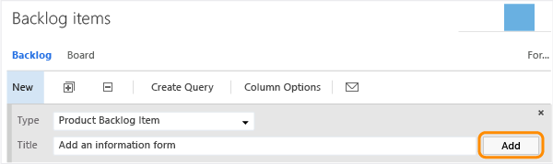

Later, you can open each PBI or bug to provide more details and estimate the effort. Also, by prioritizing the PBIs and bugs on the backlog page (which is captured in the Backlog Priority field), product owners can indicate which items should be given higher priority.

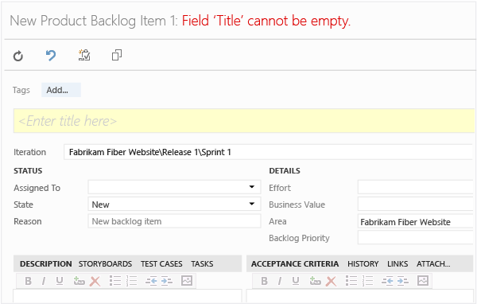

By defining the Effort for PBIs and bugs, teams can use the forecast feature and velocity charts to estimate future sprints or work efforts. By defining the Business Value, product owners can specify priorities separate from the changeable backlog stack ranking.

|  |  |
| --- | --- |
| **Field/tab** | **Usage** |
| [Effort](https://msdn.microsoft.com/en-us/library/dd997792.aspx) | Estimate the amount of work required to complete a PBI using any unit of measurement your team prefers, such as t-shirt size, story points, or time.  Agile velocity charts and forecast tools reference the values in this field. This is a required field to generate the [Release Burndown](https://msdn.microsoft.com/en-us/library/ff731579.aspx) and [Velocity](https://msdn.microsoft.com/en-us/library/ff731575.aspx) reports.  For additional guidance, see the white paper about [Estimating](https://msdn.microsoft.com/en-us/library/hh765979.aspx). |
| [Business Value](https://msdn.microsoft.com/en-us/library/dd983994.aspx) | Specify a number that captures the relative value of a PBI compared to other PBIs. The higher the number, the greater the business value. |
| [Description](https://msdn.microsoft.com/en-us/library/dd997882.aspx) (PBIs) | Provide enough detail for estimating how much work will be required to implement the item. Focus on who the feature is for, what users want to accomplish, and why. Don’t describe how the feature should be developed. Do provide sufficient details so that your team can write tasks and test cases to implement the item. |
| [Acceptance Criteria](https://msdn.microsoft.com/en-us/library/dd983994.aspx) | Define what “Done” means by describing the criteria that the team should use to verify whether the PBI or the bug fix has been fully implemented.  Before work begins on a PBI or bug, describe the criteria for customer acceptance as clearly as possible. Conversations between the team and customers to determine the acceptance criteria helps ensure a common understanding within the team to meet customers’ expectations. The acceptance criteria can be used as the basis for acceptance tests so that the team can more effectively evaluate whether an item has been satisfactorily completed. |

Use the following guidance for these essential fields. For details about creating bugs, see [Track code defects](https://msdn.microsoft.com/en-us/library/jj920147.aspx#bugs) later in this topic.

### Release Planning

* A Release is made up of multiple Sprints or Iterations
* In this session the Product Owner, ScrumMaster and Team and anyone else necessary collaborate on:
  + What to Build
  + In What Order
  + By When

Key inputs to Release Planning are:

* The Vision and Roadmap
* The Product Backlog for the product or service ordered by business value
* Team agreements on a sizing approach
* The Team’s velocity (if they have been together for a previous agile project or Scrum Team)
* The ScrumMaster should ensure that these inputs are ready so that Release Planning can be held
* ScrumMasters should coach the Product Owner on preparing the Backlog and the Team on the estimation approach

### Sprint Planning

Sprint as the Basic Unit

* For each iteration the team plans & commits to a goal that can be achieved within the Sprint
* The team performs quality development in their process using daily monitoring to inspect & adapt
* The team delivers a potentially shippable product increment reflecting on their process and course correcting if necessary
* Sprints are between 1 – 4 weeks in length
* Sprint Planning occurs for every Sprint
* The Sprint is the time box in which the team completes a working product increment
* It is important for the team to maintain the same “cadence” or Sprint length once one has been established so that a meaningful baseline is determined
* This allows the Team to consistently estimate how much work can be completed
* Part I: Determine “what” Product Backlog Items will be completed in the Sprint by the Team (the Goal)
* Part II: Determine “how” the work will be completed in the Sprint by the Team (the Tasks)
* The Product Owner sets priority, answers Definition of Done questions and works with the Team to establish the Sprint Goal based on the Team’s Velocity
* The Team breaks the PBIs down into Tasks sizing them in Hours
* The ScrumMaster facilitates keeping the meeting moving and ensuring that the Scrum framework is being followed

Sprint Planning: Capacity vs. Velocity

* Capacity is how much time the Team has available to work during the Sprint
* Consider any time needed for meetings, planned time off for any Team members, etc.
* Velocity is the amount of work that the Team is historically capable of producing based on data
* It is important for the Sprint length to remain consistent for the Team to establish a cadence and to be able to establish Velocity

How Long is Sprint Planning?

* Sprint Planning is meant to be a brief ceremony for the Team to authentically commit to Product Backlog Items without overloading their bucket
* This session has a “rule of thumb” that says the session should be 2 hours or less for every 1 week of the Sprint:
  + 1 Week Sprint = 2 Hour Sprint Planning or Less
  + 2 Week Sprint = 4 Hour Sprint Planning or Less
  + 3 Week Sprint = 6 Hour Sprint Planning or Less
  + 4 Week Sprint = 8 Hour Sprint Planning or Less

### Daily Scrum

* Daily Planning occurs at the Daily Scrum or “Stand Up”
* This is not a status meeting – it is an Inspect and Adapt mechanism for the Team to Transparently discuss any challenges they are facing in achieving the Sprint Goal
* This allows the Team to make real time course corrections
* This ceremony is 15 minutes long
* Three questions:
  + What did I do yesterday that helped the Team meet the Sprint Goal?
  + What will I do today to help the Team meet the Sprint Goal?
  + Do I see any impediment that prevents me or the Team from meeting the Sprint Goal?

### Sprint Review

* Team demonstrates what they accomplished during the Sprint to the Product Owner and Stakeholders, Users, etc.
* Incomplete or rejected items return to the Product Backlog
* New Product Backlog Items or User Stories added to the Product Backlog as necessary
* The Team who did the work demonstrates the working product increments
* The Product Owner can assist with this session by “setting the stage”

How Long is a Sprint Review?

* This session has a “rule of thumb” that says the session should be 1 hour or less for every 1 week of the Sprint:
  + 1 Week Sprint = 1 Hour Sprint Review or Less
  + 2 Week Sprint = 2 Hour Sprint Review or Less
  + 3 Week Sprint = 3 Hour Sprint Review or Less
  + 4 Week Sprint = 4 Hour Sprint Review or Less
* Start with the suggested timebox – it can always be adjusted down as everyone matures with this process and ceremony

### Spring Retrospective

* Inspect and adapt mechanism for the Team to make adjustments to their process or how they do work for the next Sprint
* Celebrate successes in addition to examining what did not go so well
* Team decides which items from their brainstormed list to put into action for the next Sprint
* Several approaches for facilitating this session are shared by Esther Derby and Diana Larsen in “Agile Retrospectives”
* Held after Sprint Review
* ScrumMaster facilitates

|  |  |
| --- | --- |
| What went well? | What did not go so well? |
| * Celebrate good team behavior * Recognize simple but effective things * Focus on the Team dn the process, not the Product | * Identify impediments to the Team’s performance * Were there any attempts to improve that failed? * Try to focus on those items within the Teams’s control – don’t dwell on the external factors |

* This is a Team decision and should not be a record of “who said what”
* The Team decides which items they will commit to putting into practice for the next Sprint
* The Team should choose a few items that can realistically be changed about their process in the upcoming Sprint

How long is a Sprint Retrospective?

* This session has a “rule of thumb” that says the session should be 1 hour or less for every 1 week of the Sprint:
  + 1 Week Sprint = 1 Hour Sprint Retrospective or Less
  + 2 Week Sprint = 2 Hour Sprint Retrospective or Less
  + 3 Week Sprint = 3 Hour Sprint Retrospective or Less
  + 4 Week Sprint = 4 Hour Sprint Retrospective or Less
* Start with the suggested timebox – it can always be adjusted down as everyone matures with this process and ceremony

# Work Item Type States

